A Tamper-Evident Evidence Vault for AI Lifecycle Events, Decisions, and Audit Packs
Alternate titles: The AI Evidence Vault: Durable Custody for Governance Receipts | Cryptographic Custody for AI Evidence
Denzil Greenwood
Founder and Head Researcher, CognitiveInsight.ai
April 2026

Abstract
AI governance programs increasingly depend on record-keeping, traceability, and lifecycle oversight, yet the underlying evidence is often stored in places optimized for operations rather than custody. Logs roll over, dashboards mutate, tickets separate approvals from technical state, and ordinary data stores preserve bytes without preserving independently verifiable chain-of-evidence. This paper argues that high-stakes AI requires a dedicated evidence vault: a custody layer that canonicalizes evidence objects, applies cryptographic integrity controls, preserves linkage across lifecycle events, and reconstructs inspection-ready audit packs without requiring the verifier to trust the originating application. The paper defines the evidence object model, explains canonicalization, hashing, Ed25519 signatures, hash chaining, and Merkle batching in operational terms, and positions the vault as the storage and verification substrate of AI Governance Evidence Infrastructure. Its central claim is that evidence has limited assurance value if it cannot be durably stored, independently verified, and reconstructed into audit-ready bundles for audits, incidents, and disputes.

Keywords: AI governance evidence infrastructure; evidence vault; chain-of-evidence; Ed25519; Merkle batching; audit packs; lifecycle accountability

1. Introduction
AI governance produces a growing volume of artifacts, but artifact volume is not the same as custody. In many organizations, lifecycle evidence is scattered across log stores, ticketing systems, model registries, file shares, dashboards, and cloud object storage. Those systems are useful, but they are usually optimized for operations, collaboration, or analytics rather than for durable evidentiary assurance.
That distinction matters because emerging governance expectations increasingly emphasize record-keeping, traceability, and lifecycle accountability. NIST AI RMF 1.0 frames governance as a cross-cutting function across the AI lifecycle, while the EU AI Act requires automatic logging capabilities for high-risk systems in support of traceability and post-market oversight [1][2]. Once the question becomes not merely whether an event was observed, but whether it can be independently verified later, the storage layer becomes central rather than secondary.
This paper addresses that custody problem. It proposes the evidence vault as the storage and verification substrate for AI Governance Evidence Infrastructure. The vault is not a generic data lake, not a conventional SIEM, and not merely immutable object storage. It is the layer that turns lifecycle receipts and supporting artifacts into verifiable evidence objects with stable identifiers, integrity protections, linkage records, and reproducible export paths.
The paper is architectural and operational. It explains what must be stored, how the stored objects are protected, how a verifier checks them, and how an auditor or investigator reconstructs a usable evidence bundle. Its central claim is straightforward: evidence has little assurance value if it cannot be durably stored, independently verified, and reconstructed into inspection-ready audit packs.

2. Design Requirements
A credible AI evidence vault must satisfy six requirements.
First is integrity: stored evidence must resist silent alteration, and tampering must be detectable. NIST describes secure hash algorithms as producing digests that can be used to detect whether messages have changed since the digests were generated [3]. In practice, that means evidence objects require canonical forms and stable digest generation before storage and export.
Second is provenance. A vault must preserve not only isolated objects but their lineage relationships: which receipt points to which dataset root, which approval refers to which evaluation bundle, which runtime action follows which policy check, and which audit pack assembles which chain. Without linkage, a vault becomes a bag of artifacts rather than a custody system.
Third is retention discipline. High-stakes assurance requires evidence to remain available for audits, incidents, supervisory review, or disputes after ordinary operational systems may have rotated data away. The design therefore must support durable storage classes, hold policies, and immutable retention modes where warranted.
Fourth is access control. Evidence often contains sensitive prompts, outputs, model identifiers, decision context, user references, or internal control logic. The vault must support role-based and purpose-based access, separation of duties, and query patterns that allow metadata inspection without necessarily exposing sensitive payloads.
Fifth is portability. Evidence must be exportable in a form that can be verified outside the producing application or cloud account. This is where ordinary application storage often fails: it assumes the reader will trust the application context. A proper vault instead assumes a skeptical verifier.
Sixth is independent verification. The originating application should not be the sole authority on whether stored evidence is authentic. The vault therefore needs cryptographic verification workflows, reproducible manifests, and the ability to validate signature chains and batch membership externally. Ed25519, specified in RFC 8032, is attractive here because it provides deterministic digital signatures with compact keys and signatures, making it suitable for portable receipt verification workflows [4].

3. Evidence Object Model
The vault stores four broad object types: receipts, supporting artifacts, linkage records, and audit-pack manifests. Receipts are the primary accountability unit. They describe governance-relevant events such as dataset registration, training execution, evaluation completion, deployment approval, runtime policy check, agent tool invocation, denial, or incident escalation. A receipt should be small, structured, and self-describing enough to verify independently.
Supporting artifacts contain the larger or richer materials referenced by receipts: evaluation reports, policy bundles, signed approvals, prompt-context snapshots, model cards, screenshots retained for explanatory context, exported output files, or investigation notes. These are not the primary proof object, but they become essential when an audit or dispute requires deeper inspection.
Linkage records bind objects together when one object should not embed another in full. A linkage record may connect a runtime action receipt to a policy-check receipt, a model-promotion receipt to a validation bundle, or an audit-pack manifest to the collection of evidence object identifiers it contains. This allows the vault to preserve a graph of evidence without forcing all evidence into a single monolith.
Audit-pack manifests are special-purpose export objects. They declare the scope, included objects, hash values, signature metadata, assembly timestamp, requesting actor, and export purpose for an inspection-ready package. The manifest becomes the verifier’s entry point when reviewing a packaged set of evidence.
To support stable retrieval, each object should be content-addressed or otherwise bound to a persistent identifier derived from canonicalized content. Content-addressing is especially useful because it separates object identity from storage location; the object can move between storage classes or cloud environments without changing its digest identity, provided canonicalization is stable.
[Figure 1 here - Vault architecture diagram showing receipt ingestion, canonicalization, signing, indexing, storage tiers, and audit-pack export.]
Placeholder only. Replace with a finished diagram in the next drafting round.

Figure 1 Vault Architecture:
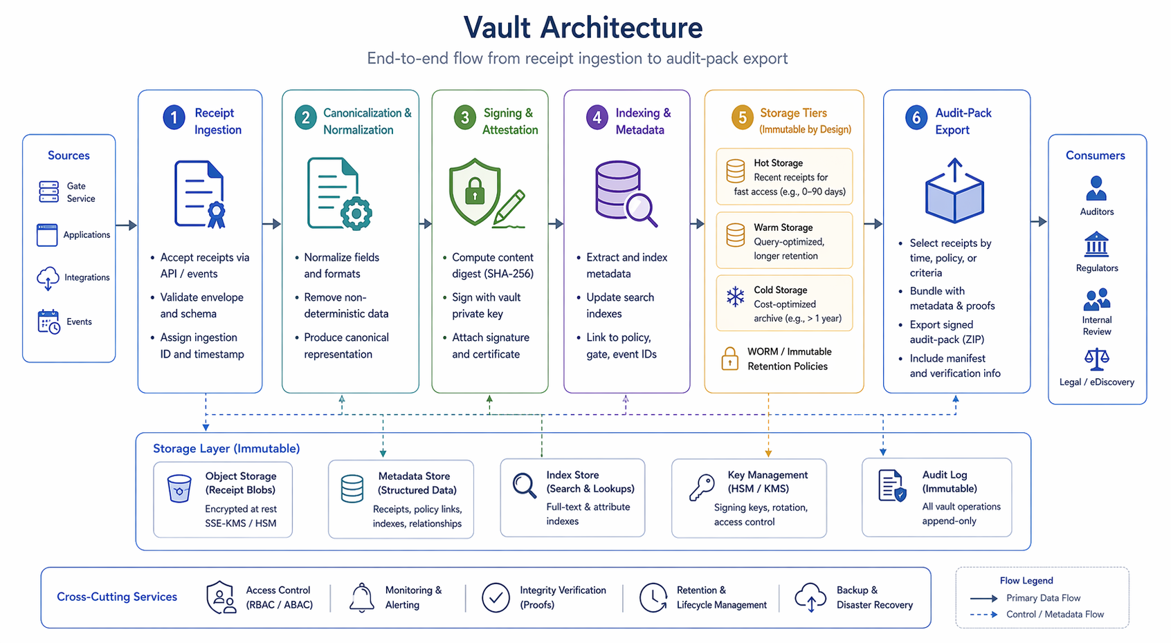
Figure 1: Vault Architecture:
diagram showing receipt ingestion, canonicalization, signing, indexing, storage tiers, and audit-pack export

4. Integrity Mechanisms
The vault’s integrity model begins with canonicalization. Evidence objects frequently originate as JSON, protobuf payloads, XML fragments, event rows, or documents with ordering ambiguities. Canonicalization reduces those ambiguities by enforcing deterministic field ordering, encoding, line-ending treatment, null handling, and versioned serialization rules. Without this step, the same semantic object may hash differently across systems, undermining verification and portability.
After canonicalization, the object is hashed. SHA-256 remains a practical choice because it is standardized by NIST and widely implemented in verification tooling [3]. The resulting digest becomes both a tamper-detection primitive and, in content-addressable designs, part of the object identifier. Hashes alone, however, do not authenticate who asserted the object. That is the role of signatures.
For signatures, this paper assumes Ed25519 as the default receipt-signing algorithm. RFC 8032 specifies Ed25519 as an instance of EdDSA over Curve25519 and provides interoperable algorithm definitions and test vectors [4]. Operationally, Ed25519 is appealing because signatures are compact, verification is efficient, and deterministic signing reduces implementation variance relative to schemes that depend on per-signature randomness. The vault should store key identifiers, signature algorithm metadata, and canonicalization-version references alongside each signed object.
Beyond individual objects, the vault should preserve sequence integrity. Hash chaining is a simple mechanism for this: each receipt includes the digest of the immediately preceding receipt within a defined stream or scope, such as a deployment sequence, a runtime session, or a case record. Hash chaining makes deletion or reordering more obvious because a broken chain invalidates downstream linkage.
Merkle batching adds a second level of integrity efficiency. Rather than anchoring every object individually, the vault can batch many object digests into a Merkle tree and retain the Merkle root plus inclusion proofs. This supports efficient third-party verification of membership in a batch without re-transmitting the full batch contents. The operational value is twofold: lower anchoring overhead and stronger exportability for audit packs that need to prove inclusion in an immutable batch window.
Anchoring policy is an architectural decision. Some deployments may anchor roots to an internal transparency ledger, some to write-once storage with signed manifests, and some to an external notarization service. The important property is not one specific anchor destination but the ability to prove that a given object was included in a sealed batch at or before a specific time and that subsequent modification would be detectable.
Figure 2: Merkle Batching and Anchoring
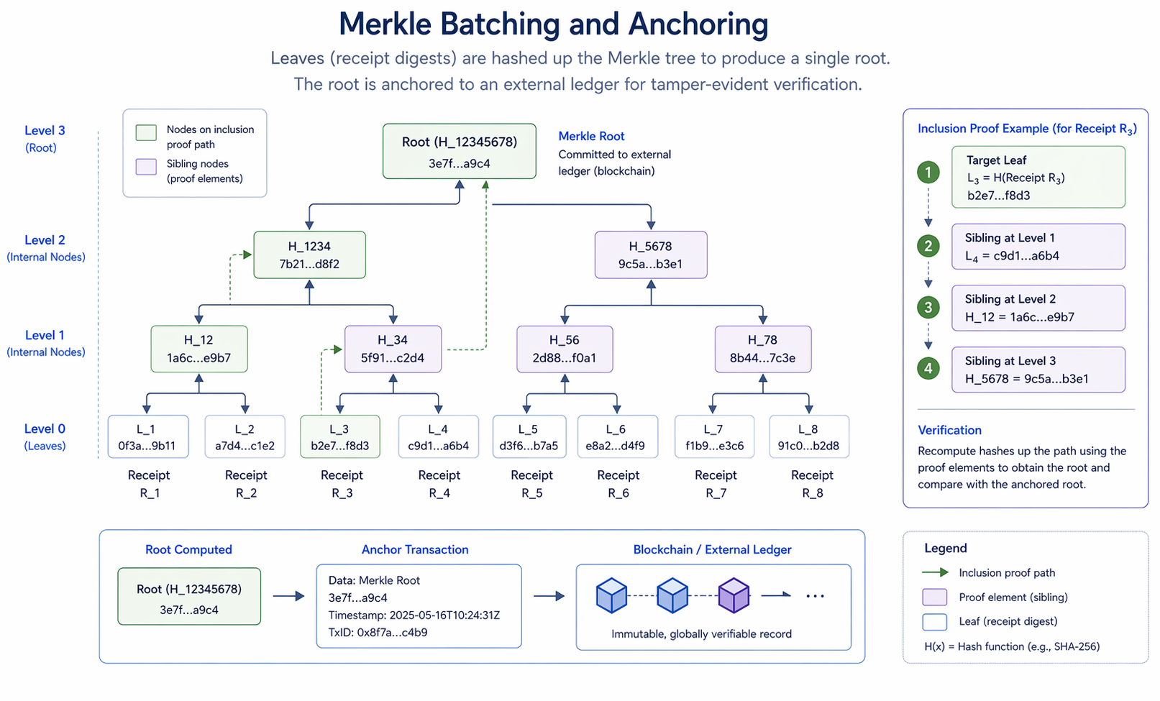
Figure 2: Merkle batching and anchoring illustration showing leaf digests, internal nodes, root, and inclusion proof path.

5. Storage and Retrieval Architecture
A vault differs from ordinary log storage because it treats evidence objects and their metadata as first-class custody units. Ingestion should therefore separate at least three concerns: object preservation, metadata indexing, and policy enforcement. The preserved object lives in durable storage; the index maintains searchable metadata and graph relationships; and policy enforcement governs retention, access, and export rules.
In a practical implementation, raw objects may live in immutable object storage or a WORM-capable store, while metadata and linkage edges are indexed in a relational or document database optimized for query. This split architecture allows the vault to preserve large artifacts cheaply while still supporting fast lookup by case identifier, model version, actor, date range, gate type, policy ID, or incident number.
Retrieval must support both investigative browsing and formal export. Investigative browsing usually begins with metadata: an auditor asks which deployment approvals exist for a model version, or an investigator asks which runtime actions occurred within a session. Formal export is different. It requires the vault to gather the relevant objects, verify their current integrity status, assemble them into a manifest-governed package, and record that export as an evidence event of its own.
The audit-pack assembly flow should be deterministic. Given the same manifest request and the same vault state, the resulting package should contain the same object identifiers, the same digests, and the same verification materials. This reproducibility matters because a package that cannot be reproduced later is difficult to defend in a dispute.

6. Verification Workflows
The evidence vault is designed so that a verifier need not trust the producing application. A basic verification workflow starts with a receipt file and its associated metadata. The verifier applies the declared canonicalization rules, recomputes the hash, checks that it matches the stored digest, verifies the Ed25519 signature against the declared public key, and confirms that the key identifier is authorized for the claimed receipt type and period [4].
If the receipt belongs to a chained sequence, the verifier next checks predecessor references. If the receipt belongs to a Merkle batch, the verifier checks the inclusion proof against the retained Merkle root. If the root was further anchored or notarized, that anchor proof is checked as well. None of these steps require the original application server to answer the question “is this authentic?” The object carries the information needed for independent verification, and the vault carries the supporting proof structures needed for chain validation.
A stronger workflow applies this process to an entire audit pack. The verifier confirms that every listed object exists in the package, that every digest matches, that every signature verifies, that all internal cross-references resolve, and that the package manifest itself is signed. The outcome is not merely confidence that files were copied correctly, but confidence that the custody narrative represented by the package is internally consistent and cryptographically checkable.
This external-verifier model is one of the clearest differences between an evidence vault and ordinary application storage. In ordinary storage, trust often inheres in the operator. In a vault, trust shifts toward the evidence structures themselves.

Capability | Ordinary Logs | SIEM Storage | Data Lakes | Evidence Vault
Primary purpose | Operational troubleshooting and basic activity recording | Security monitoring, correlation, alerting, and incident investigation | Large-scale storage and analysis of raw or semi-structured data for analytics, ML, and reporting | Preservation of governance, decision, and lifecycle evidence for audit, review, disputes, and assurance
Mutability | Often editable, rotated, overwritten, truncated, or deleted under retention settings | Usually retained under platform controls, but still administrator-managed and not inherently immutable | Frequently transformed, re-partitioned, overwritten, deduplicated, or reprocessed | Designed for append-only or strongly tamper-evident storage, often with WORM, signed records, or immutable commitment structures
Identity model | Usually system-, host-, app-, or service-generated identifiers; identity context may be inconsistent | Stronger identity correlations across users, devices, hosts, accounts, and events, but often normalized for security operations | Identity is usually analytical metadata, not a custody-grade actor model | Explicit actor, system, model, workflow, policy, and key identity bound to each receipt or evidence object
Linkage strength across events | Weak to moderate; correlation often depends on timestamps, request IDs, or ad hoc parsing | Moderate to strong for security use cases through correlation rules, enrichment, and detection logic | Weak by default; linkage is typically reconstructed through ETL, joins, and data modeling | Strong by design; evidence objects are intentionally linked through hashes, signatures, policy versions, lifecycle references, and chain-of-custody structures
Exportability for audit/review | Possible, but often noisy, incomplete, format-specific, and hard to interpret outside the originating system | Exportable, but usually optimized for analysts and incident response rather than formal audit packages | Exportable for analytics use, but not usually packaged as defensible evidence bundles | Intended to support portable evidence packages, receipts, proofs, manifests, and review-ready audit exports
Independent verification | Limited; typically requires trusting the source system and its administrators | Limited to moderate; verification usually depends on trusting the SIEM platform and ingestion pipeline | Limited; integrity depends largely on platform governance and data engineering controls | High; supports cryptographic verification, tamper-evidence, provenance checking, and potentially third-party or externally anchored validation

Table 1. Comparison of conventional telemetry and storage patterns versus the evidence vault. Ordinary logs, SIEM platforms, and data lakes are useful operational systems, but they are generally not designed as independent, cryptographically verifiable evidence-preservation layers.

7. Operational Use Cases
An audit request is the most straightforward use case. Suppose internal audit requests proof that a high-risk model promotion complied with validation and approval requirements during a defined quarter. The vault query would locate promotion receipts, associated validation bundle receipts, approval receipts, and any override or denial records. The resulting audit pack would include the receipts, signature metadata, relevant supporting artifacts, and a manifest showing package scope and integrity materials. Because the package is content-addressed and signed, it can be re-verified later without reopening the live application stack.
Incident reconstruction is more dynamic. Suppose an agent took an external action that later triggered a customer complaint or regulatory review. The vault can reconstruct the runtime chain: policy-check receipt, scoped authorization receipt, action execution receipt, downstream artifact hash, escalation notes, and any subsequent denial or containment actions. The value is not only chronology but integrity-preserving chronology.
A disputed model action provides a third use case. Consider a claim that a specific output or approval did not come from the asserted model state or did not pass the asserted control gate. The vault can test that claim directly by verifying the relevant receipts, their predecessor links, their model and policy references, and any included artifact-level provenance markers or digests. In this way the vault functions not merely as storage but as a dispute-resolution substrate.

Figure 3: Audit Pack Assembly
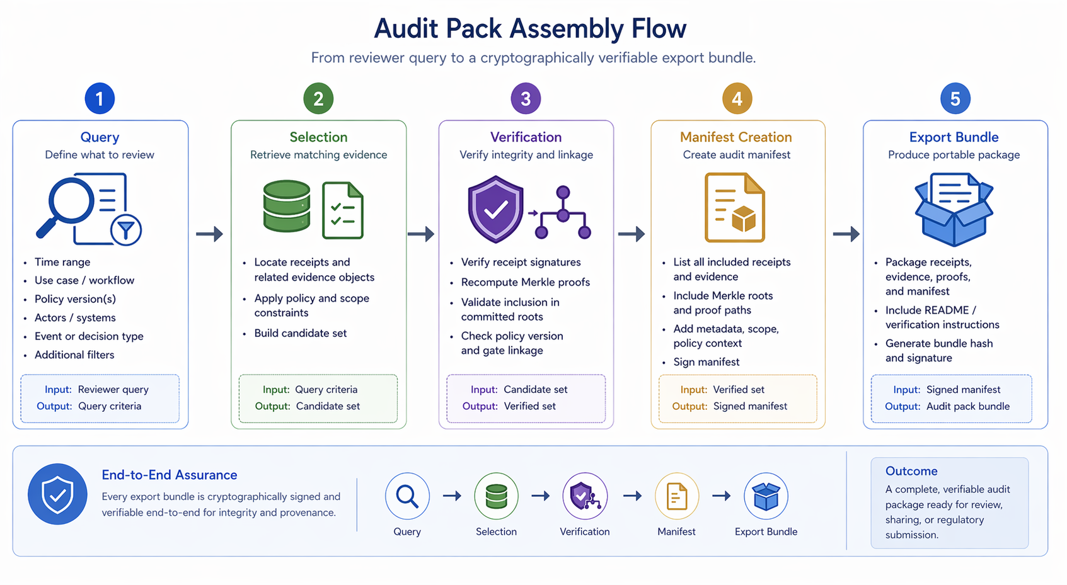
Figure 3 here - Audit pack assembly flow from query -> selection -> verification -> manifest creation -> export bundle

8. Limitations and Governance of the Vault
A vault does not eliminate governance risk; it relocates part of it into the evidence layer itself. Key management becomes critical because compromised signing keys undermine receipt trust. The operational design therefore needs key rotation, separation of duties, revocation handling, and ideally hardware-backed protection for high-assurance signing operations.
Privacy is another constraint. Evidence useful for assurance may also contain sensitive business logic, customer data, protected health information, or prompt-context material. Retention and export rules must therefore reflect minimization principles, lawful basis, role restrictions, and redaction or envelope-encryption patterns where appropriate. A vault that preserves everything indiscriminately can become a liability.
WORM policy is likewise not absolute. Some regimes or internal practices require strict immutability for defined record classes; others require deletion after a retention horizon or after legal hold release. The vault must therefore distinguish between object immutability, metadata mutability for administrative overlays, and policy-governed destruction workflows. Precision is better than blanket slogans about immutability.
Independence questions also remain. A first-party vault can materially improve assurance, but some use cases may call for third-party custody, external notarization, or cross-organizational verification services. The more adversarial or high-stakes the context, the more attractive independent custody becomes. This paper does not prescribe one institutional model, but it does argue that the vault should be designed from the outset to support skeptical external review rather than only trusted internal use.

9. Conclusion
The evidence vault is the custody substrate of AI Governance Evidence Infrastructure. It converts lifecycle receipts and supporting artifacts into durable, verifiable evidence objects that can survive beyond ephemeral operational contexts. By combining canonicalization, hashing, signatures, linkage records, sequence integrity, and deterministic audit-pack assembly, the vault makes governance evidence portable and independently checkable rather than merely observable.
This matters because high-stakes AI accountability is ultimately tested under conditions of inspection, incident, dispute, and delay. It is not enough that an application once displayed an approval or once emitted a log line. The evidence must still exist, still verify, and still reconstruct into a coherent chain later. That is the problem the vault solves.
The broader architecture depends on this layer. CIAF-LCM generates lifecycle receipts; governance gates generate control outcomes; agent governance and artifact provenance generate additional evidence-bearing events. The vault is where those materials become durable custody. The next paper in the series can therefore move from storage to action by examining agent governance planes and proof-carrying runtime control in agentic systems.

Appendix A. Minimal Receipt Schema Example
Below is a minimal illustrative receipt schema. The example is deliberately compact so that later papers can extend it without changing the core custody model.
Field | Required | Example | Purpose
receipt_id | Yes | rcpt:sha256:... | Stable identifier for the evidence object
receipt_type | Yes | deployment_approval | Declares event class and schema family
canonicalization_version | Yes | ciaf-json-v1 | Tells the verifier how bytes were normalized
object_hash | Yes | sha256:... | Digest of the canonicalized receipt payload
signature | Yes | eddsa-ed25519:... | Authenticates issuer assertion over the digest
key_id | Yes | kms/prod/signing/2026-01 | Binds signature to a verifiable public key
timestamp_utc | Yes | 2026-04-18T14:33:02Z | Evidence time for issuance
references | Optional | [validation_bundle_id,...] | Links related evidence objects without full embedding
policy_context | Optional | gate=approval; policy_id=... | States which control or gate context applied
prev_receipt_hash | Optional | sha256:... | Supports hash chaining inside a scoped sequence
Table A1. Minimal illustrative receipt schema for vault ingestion and external verification.

References
[1] NIST, Artificial Intelligence Risk Management Framework (AI RMF 1.0), 2023. https://nvlpubs.nist.gov/nistpubs/ai/nist.ai.100-1.pdf
[2] European Commission AI Act Service Desk, Article 12: Record-keeping. https://ai-act-service-desk.ec.europa.eu/en/ai-act/article-12
[3] NIST, FIPS 180-4 Secure Hash Standard (SHS). https://csrc.nist.gov/pubs/fips/180-4/upd1/final
[4] RFC 8032, Edwards-Curve Digital Signature Algorithm (EdDSA), RFC Editor, 2017. https://www.rfc-editor.org/rfc/rfc8032.html

AI uses disclosure:

This document, "AI Governance Evidence Infrastructure: A Category Framework for Cryptographically Verifiable AI Lifecycle Accountability," was prepared for concept development and publication planning, dated April 18, 2026. It was authored by Denzil Greenwood, Founder and Head Researcher at CognitiveInsight.ai.
In the creation of this document, AI tools were utilized to generate both the text and the supporting images, with human oversight applied to both processes.

Research Papers and Continued Work: AI Governance Evidence Infrastructure
- Cognitive Insight Audit Framework Lazy Capsule Materialization (CIAF-LCM)
- Tamper-Evident Evidence Vault for AI Lifecycle Events, Decisions, and Audit Packs
- Dual-Layer Provenance for AI-Generated Artifacts: Explicit Watermarks and Forensic Fingerprints as Evidence Infrastructure
- Governance Planes for Agentic AI: Identity, Policy, Privilege, Execution, and Evidence
- Shadow AI Governance: Bringing Unmanaged AI Use into the Evidence Perimeter
- CIAF-LCM Proposed Schema Documentation: Current Schema State, Architecture Fit, and Proposed Documentation Model

